Name: Preksha Jain

SAP: 50012016

Batch: 1

**EXPERIMENT 12:**

**Title: To understand the concepts of Sequence.**

**Objective:** Students will be able to implement the concept of sequence.

1. Create a sequence by name EMPID_SEQ starting with value 100 with an interval of 1.

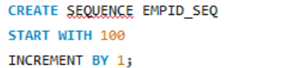

1. Write a SQL command for finding the current and the next status of  EMPID_SEQ.

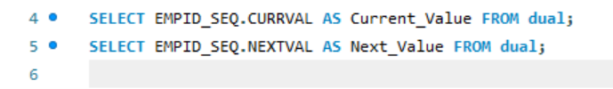

1. Change the Cache value of the sequence EMPID_SEQ to 20 and maxvalue to 1000.

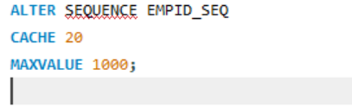

1. Insert values in employees table using sequences for employee_id column.

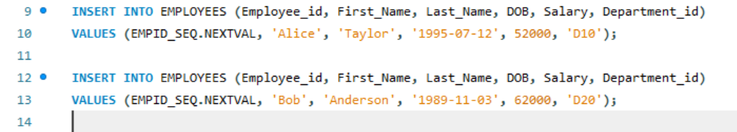

1. Drop sequence EMPID_SEQ.

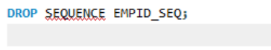

1. Create a sequence called REVERSE to generate numbers in the descending order from 10000 to 1000 with a decrement of 5.

